Mathematica Lesson: 3D Graphing

Grades: Calculus 3

1. Open the Basic Math Assistant under the palettes toolbar.
2. Click **3D** under Basic Commands and **Advanced** under Calculator

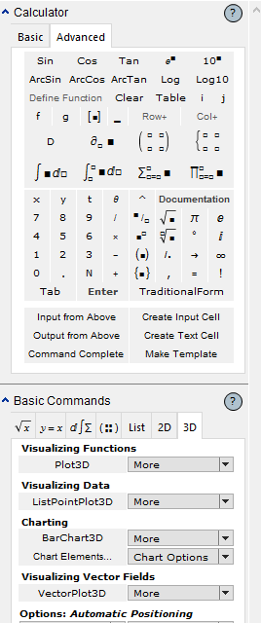

1. Click **Plot3D** and enter {x^2+y^2, 1} into function, x from 0 to 5 in the first function and y from -5 to 5 for the second function.



* 1. After inputting values press **Shift+Enter** to show graph.
  2. If you right click on it you can check out the different views from top to bottom.

1. Click below the first graph to make a new line to create second graph.
2. Click Plot 3D again and enter Cos[y]Sin[y]==Sin[x]Cos[x] for the function and for the values go from -2pi to 1.5pi for each.



1. Hit Shit+Enter to view the graph.
2. Go back to the value area and change -2pi to pi for x and y.

In the function above which axis is which?

* Right side
* Left side
* Middle
* The x axis ___________________________________________
* The y axis ___________________________________________
* The z axis ___________________________________________

1. Go to a new line and hit more next to Plot3D and click **ContourPlot3D** and enter the function x^3+y^2-z==0 and add values for x, y, and z.



* 1. Press **Shift+Enter**.
  2. If we increase the bigger number our graph changes and looks like it becomes smaller.

1. On a new line make another Plot3D command and type the function Sin[xy] and add values going from 0 to a number of your choice.
2. After the last squiggly bracket add a comma and start typing in ColorFunction.
   1. As you type the command the full one should appear in a drop down box below (First Choice).
   2. After that click the color choice you want from the given list then press **Shift+Enter**.



1. To add a texture type surface to the graph we add the **Mesh** command.
2. After the ColorFunction command add a comma and start entering the Mesh command.
   1. Drop down box should appear with the command, click on it and then choose **None** when it gives you the mesh choices.

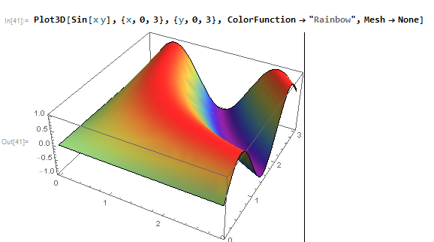

1. Do you see a difference in the graph? If so what is it? ___________________
2. Go to a new line and copy any of the first three commands.
3. 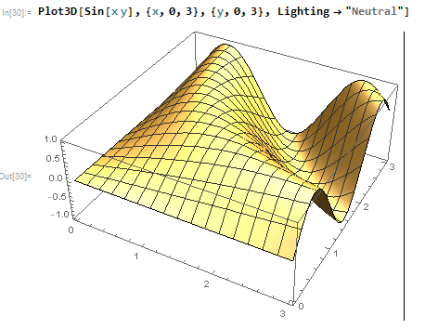At the end of it add the command Lighting, when it gives you the choices select **Neutral**.
4. If you move the graph around the light changes as if there is a spotlight on it.